ASSESSMENT TOOL 3 – INTEGRATED EXPERIMENTS
Course: Artificial Intelligence | Code: CSA17 | CO4
Student Name: BATHALA HEMANTH KUMAR
Register Number: 192324238
This document contains the two experiments specified in the uploaded assessment: (1) Decision Tree Classification and (2) Reinforcement Learning – Q-Learning.

Experiment 1: Decision Tree Classification

Objective
Implement and evaluate a Decision Tree classifier on the Iris dataset.

(a) Load, preprocess and split
The Iris dataset has 150 records, four numerical features and three classes. No missing-value handling or categorical encoding is required. A stratified 70:30 train-test split was used.
Row | Sepal length | Sepal width | Petal length | Petal width | Class
1 | 5.1 | 3.5 | 1.4 | 0.2 | setosa
2 | 4.9 | 3.0 | 1.4 | 0.2 | setosa
3 | 4.7 | 3.2 | 1.3 | 0.2 | setosa
4 | 4.6 | 3.1 | 1.5 | 0.2 | setosa
5 | 5.0 | 3.6 | 1.4 | 0.2 | setosa
The four predictors are numerical floating-point variables and the target is a class label.

(b) Decision Tree
Gini criterion, max_depth=3, random_state=42. The root feature selected in this run is petal length (cm).
|--- petal length (cm) <= 2.45
| |--- class: 0
|--- petal length (cm) > 2.45
| |--- petal width (cm) <= 1.55
| | |--- petal length (cm) <= 4.95
| | | |--- class: 1
| | |--- petal length (cm) > 4.95
| | | |--- class: 2
| |--- petal width (cm) > 1.55
| | |--- petal width (cm) <= 1.70
| | | |--- class: 1
| | |--- petal width (cm) > 1.70
| | | |--- class: 2
The root is selected by the split giving the largest impurity reduction. Petal measurements are highly discriminative in Iris because Setosa is well separated and the other two classes have partial overlap.
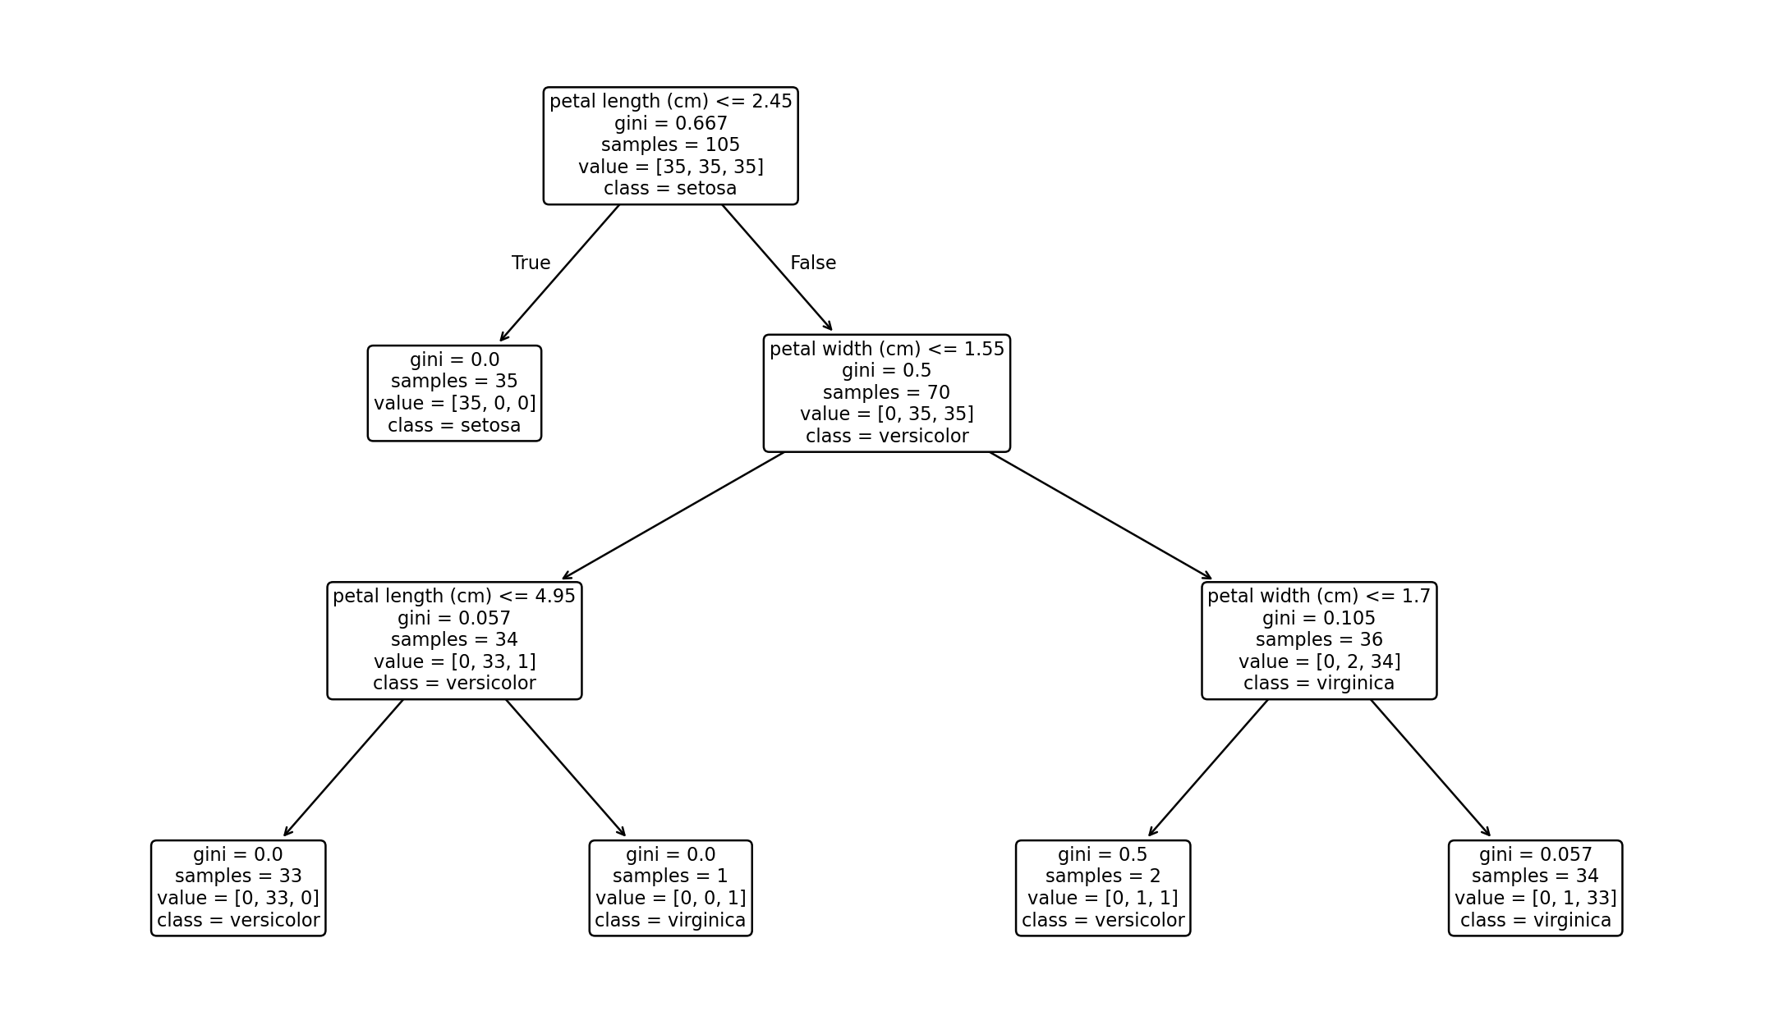
Figure 1. Decision Tree classifier.

(c) Evaluation
Metric | Result
Accuracy | 0.978
Confusion Matrix | [[15, 0, 0], [0, 14, 1], [0, 0, 15]]
Setosa precision | 1.000
Versicolor precision | 1.000
Virginica precision | 0.938
Misclassified instances in this run:
- True = versicolor, Predicted = virginica, Features = {'sepal length (cm)': 6.7, 'sepal width (cm)': 3.0, 'petal length (cm)': 5.0, 'petal width (cm)': 1.7}
The errors are mainly between Versicolor and Virginica because their feature distributions overlap.

Python Code – Experiment 1
from sklearn.datasets import load_iris
from sklearn.model_selection import train_test_split
from sklearn.tree import DecisionTreeClassifier, plot_tree, export_text
from sklearn.metrics import accuracy_score, confusion_matrix, classification_report
import matplotlib.pyplot as plt
iris = load_iris(as_frame=True)
X, y = iris.data, iris.target
print(X.head())
print(X.dtypes)
X_train, X_test, y_train, y_test = train_test_split(
X, y, test_size=0.30, random_state=42, stratify=y)
model = DecisionTreeClassifier(
criterion="gini", max_depth=3, random_state=42)
model.fit(X_train, y_train)
pred = model.predict(X_test)
print("Accuracy:", accuracy_score(y_test, pred))
print("Confusion matrix:\n", confusion_matrix(y_test, pred))
print(classification_report(
y_test, pred, target_names=iris.target_names))
print(export_text(model, feature_names=list(X.columns)))
plt.figure(figsize=(12, 7))
plot_tree(model, feature_names=X.columns,
class_names=iris.target_names, filled=True)
plt.show()
Experiment 2: Reinforcement Learning – Q-Learning

(a) Environment
Component | Definition
States | 16 cells in a 4×4 grid.
Actions | Up, Down, Left, Right
Goal | +10 at state 15
Obstacle | −5 at state 5
Normal step | −1
α | 0.1
γ | 0.9
ε | 0.2
Q-table is initialized with zeros and has dimensions 16×4.

(b) Q-table evolution
Episode | State | Q-values [Up, Down, Left, Right]
1 | 0 | [-0.199, -0.280, -0.199, -0.190]
1 | 10 | [-0.100, -0.100, -0.109, 0.000]
50 | 0 | [-2.117, -2.119, -2.141, -2.104]
50 | 10 | [0.028, -0.019, -0.202, 7.383]
100 | 0 | [-2.192, -2.150, -1.991, 0.921]
100 | 10 | [1.791, 0.940, 0.210, 7.987]
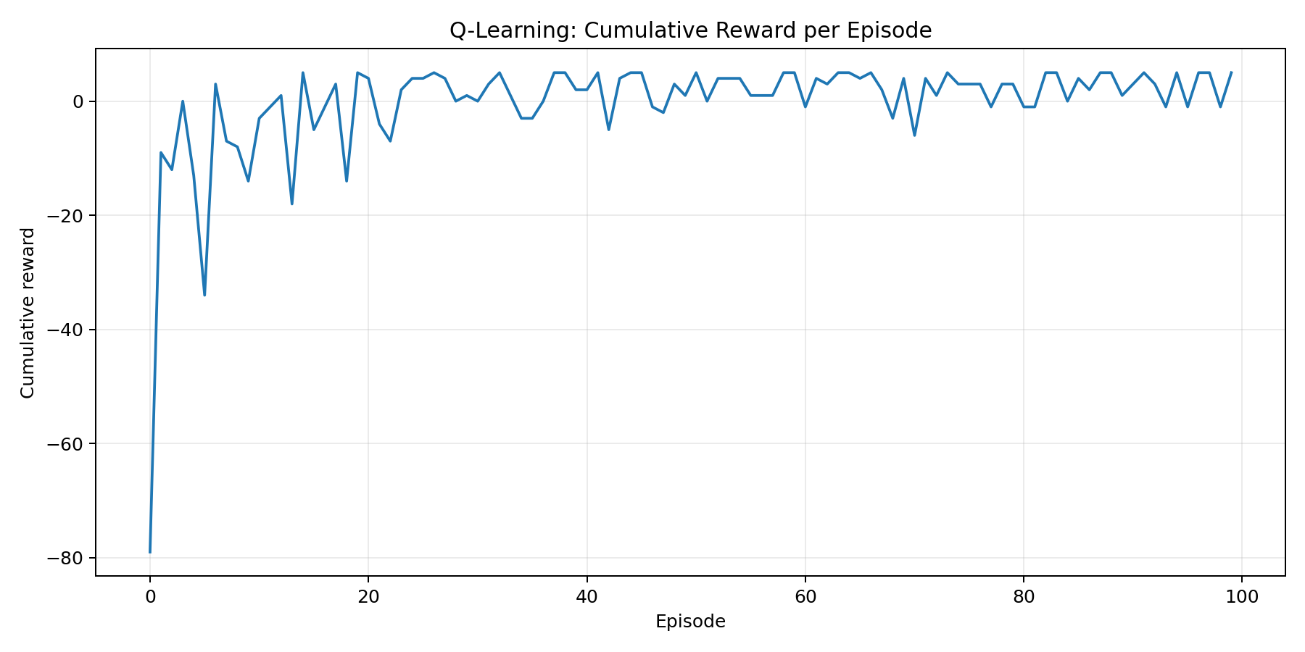
Figure 2. Cumulative reward per episode.

(c) Final learned policy
Row | Col 0 | Col 1 | Col 2 | Col 3
1 | Right | Right | Down | Down
2 | Down | Obstacle | Down | Down
3 | Right | Right | Right | Down
4 | Right | Right | Right | Goal
Convergence is indicated by improved cumulative rewards and stabilising Q-values. ε-greedy exploration causes some fluctuations because the agent occasionally chooses non-greedy actions.

Python Code – Experiment 2
import numpy as np
import matplotlib.pyplot as plt
N = 4
goal, obstacle = 15, 5
alpha, gamma, epsilon = 0.1, 0.9, 0.2
Q = np.zeros((16, 4))
def step(state, action):
r, c = divmod(state, N)
nr, nc = r, c
if action == 0: nr -= 1
elif action == 1: nr += 1
elif action == 2: nc -= 1
else: nc += 1
if nr < 0 or nr >= N or nc < 0 or nc >= N:
return state, -1, False
next_state = nr*N + nc
reward = -5 if next_state == obstacle else 10 if next_state == goal else -1
return next_state, reward, next_state == goal
rewards = []
for episode in range(100):
state, total = 0, 0
for _ in range(100):
action = np.random.randint(4) if np.random.rand() < epsilon else np.argmax(Q[state])
next_state, reward, done = step(state, action)
target = reward if done else reward + gamma*np.max(Q[next_state])
Q[state, action] += alpha*(target - Q[state, action])
total += reward
state = next_state
if done: break
rewards.append(total)
policy = np.argmax(Q, axis=1)
print("Final Q-table:\n", Q)
print("Final policy:", policy)
plt.plot(rewards)
plt.xlabel("Episode")
plt.ylabel("Cumulative Reward")
plt.title("Q-Learning Convergence")
plt.show()

